**INVESTMENT DECISION IN CANADA**

Problem: A group of investors wants to invest in Canada. They already have many business around the world. Because of that diversification they does not have any preference when investing as a result of their risk profile. Therefore, they need to know which kind of businesses are the most popular in Canada and in which neighborhoods are concentrated the greater number of those type of business.

**Data Sources**

* There are three source of data, as follow:
* Neighborhood data will be extracted from this Wikipedia website:

"https://en.wikipedia.org/wiki/List_of_postal_codes_of_Canada:_M"

* Latitude and longitude data are extracted from the csv file provided by coursera course
* Venues from each neighborhood were extracted from Foursquare database

**Methodology**

Neighborhood and coordinate data were merged to get the dataframe need to perform the analysis, then venues data was extracted from foursquares database. After this different analysis were perform to solve the problem, such as which are the top 10 venues most common in each neighborhood and which are the most popular along all neighborhoods.

**Results**

It is clear that coffee shops are the most common venue along all neigborhoods, not just is the first most popular venue in 20 neighborhoods but the second one as well in over 10 of them.

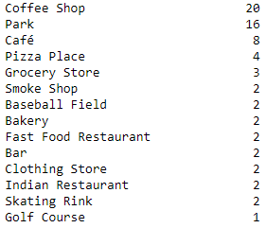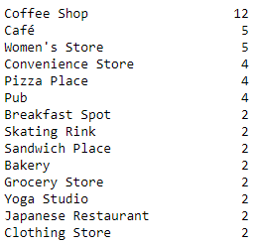

1st most common venue

2nd most common venue

This is a comprehensive list of the top 10 most common venues per neighborhood in Canada.

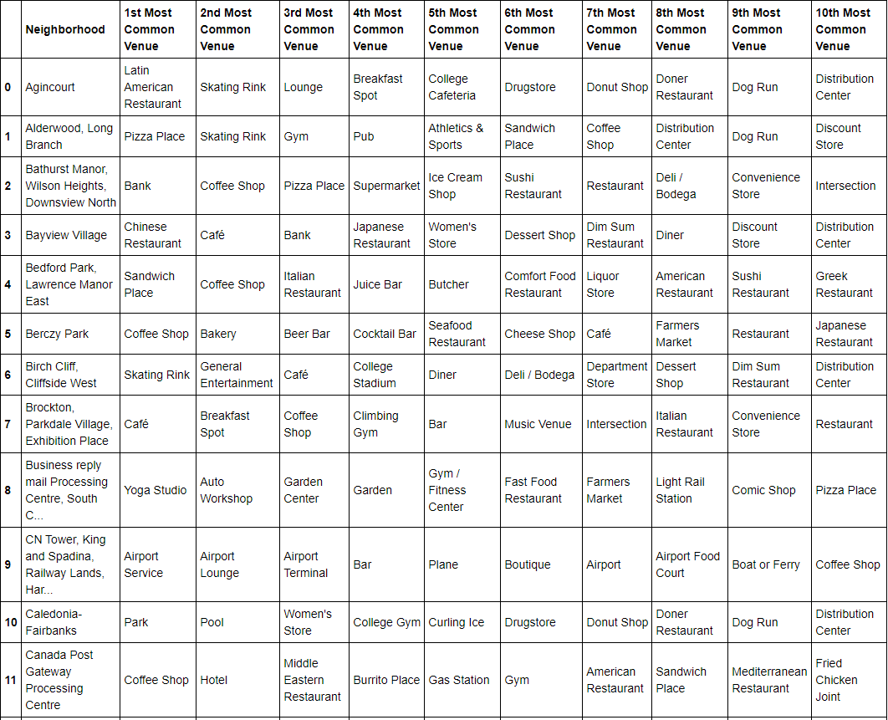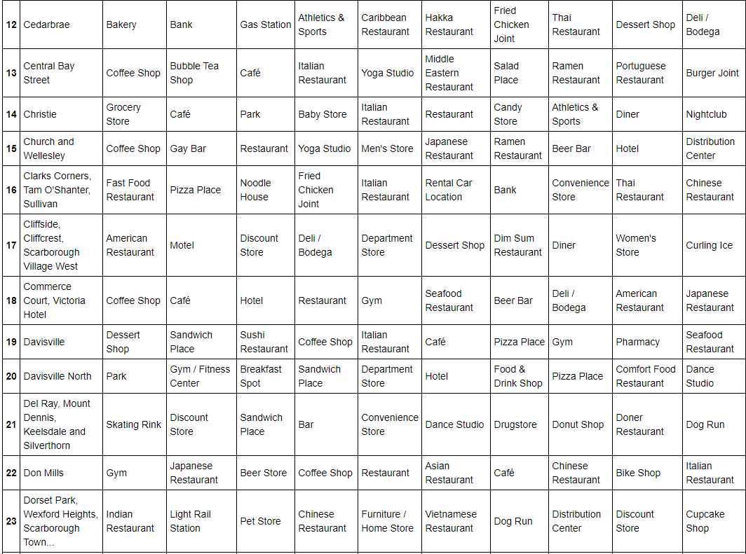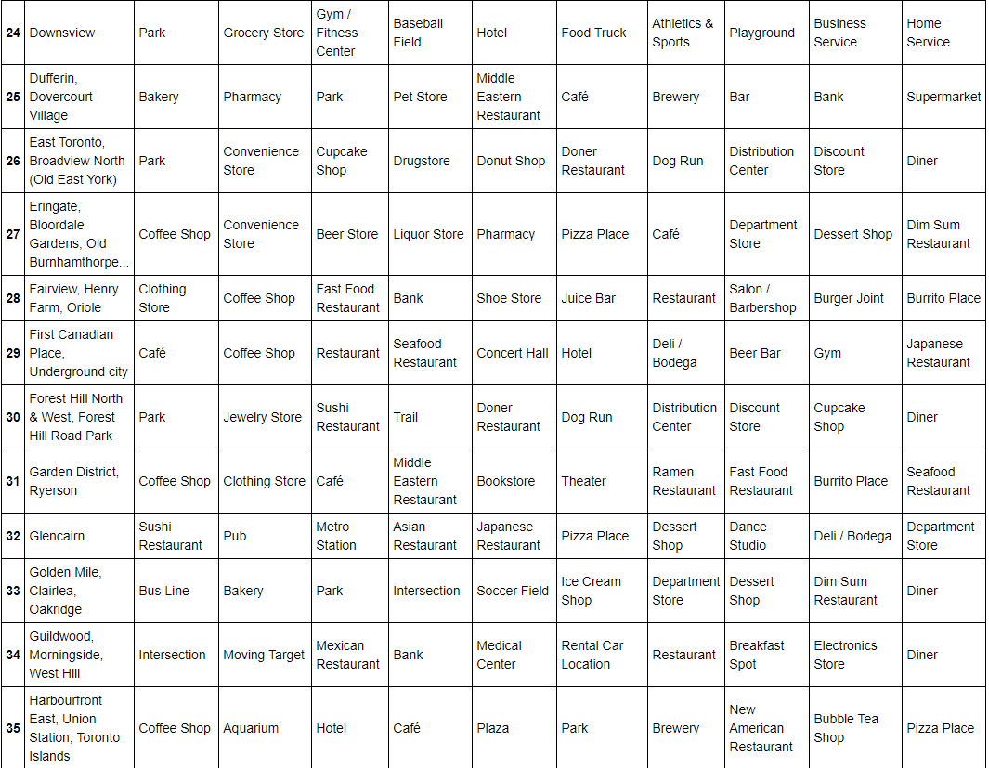

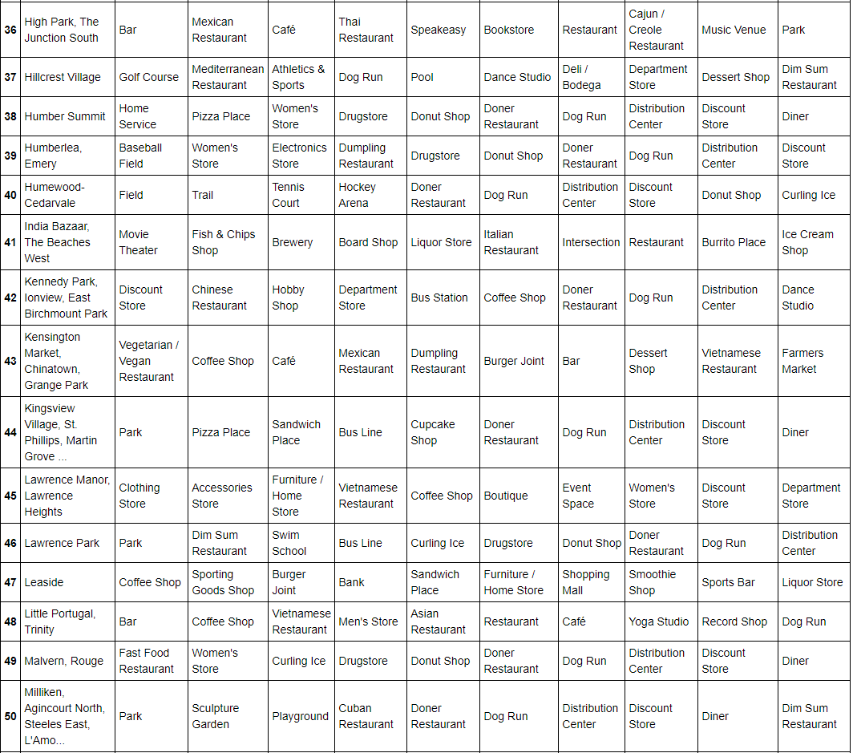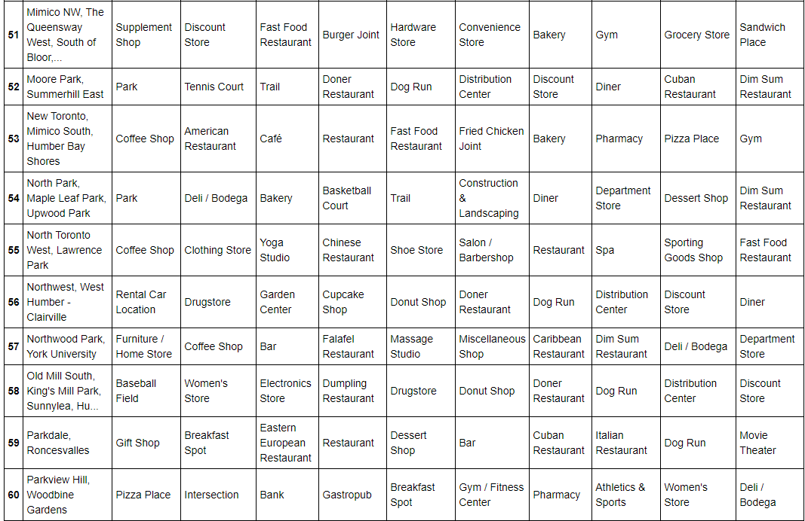

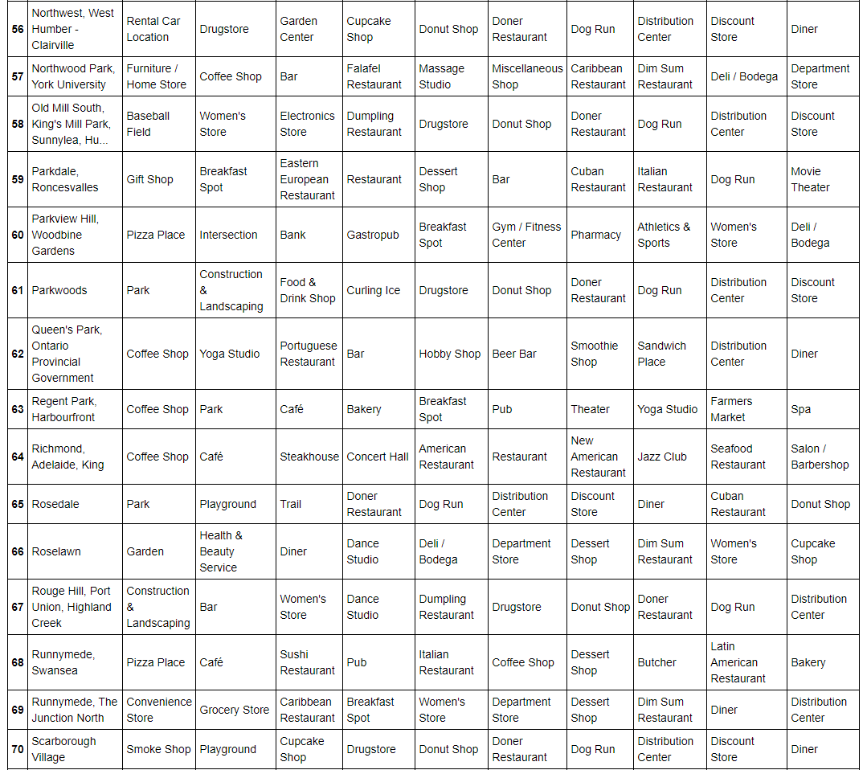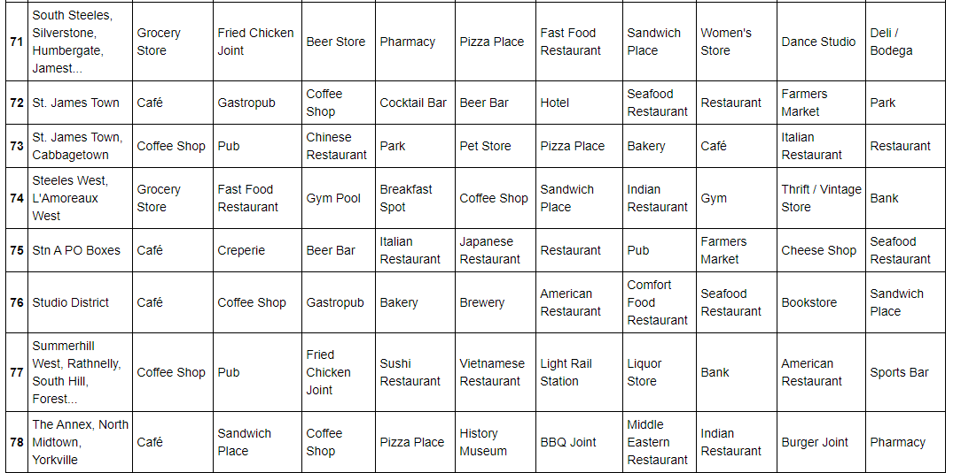

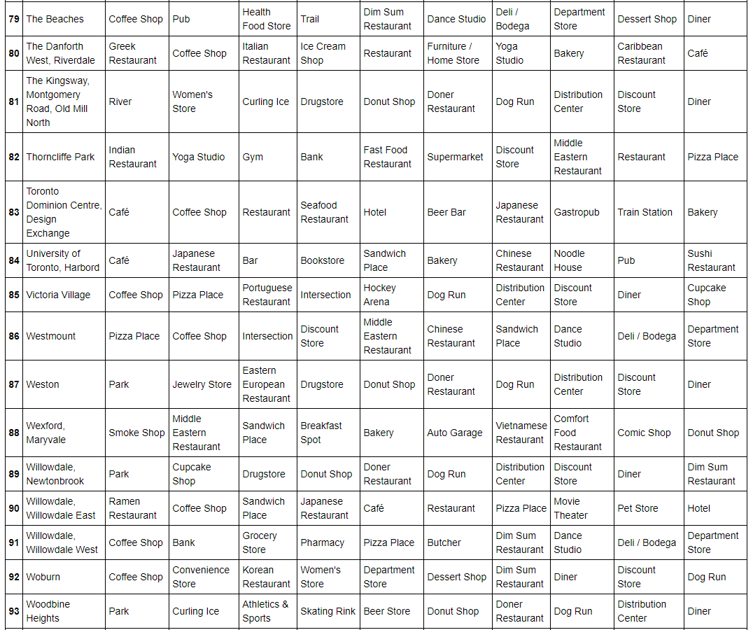

**Observations & Recommendations**

The analysis suggest that coffee shops are the most common business along all neighborhoods in Canada. With an aggressive marketing campaign, it is possible to enter to the coffee market, compete and gain a reasonable proportion of the market, starting in those neighborhoods were that kind of business is the most popular.

Further analysis can provide the best option within the neighborhoods where coffee shops are popular.

**Conclusion**

This analysis helps to solve the investment decision problem about in which business and neighborhoods is convenient to invest. Also, this analysis left some questions for further analysis, because the list of potential neighborhoods where investing is a good option is large (20), so it could be appropriate to analyze with additional information and get a short list for the best options.